**Online Analysis Website**

A Project Report Submitted in Partial Fullfillment of the requirements

For the award of the degree of

**Bachelor of Degree**

**In**

**Computer Science And Engineering**

**by**

Himanshu Sharma (171500138)

Jyoti Gupta (171500149)

Muskan Varshney (171500197)

Varsha Varshney (171500375)

Under the Guidance of

**Mr. Pankaj Kapoor**

**(Asst. Professor)**

Department of Computer Engineering & Applications

**Institute of Engineering & Technology**



**GLA University**

**Mathura- 281406, INDIA**

**2019**



**Department of computer Engineering and Applications**

**GLA University, Mathura**

**17 km. Stone NH#2, Mathura-Delhi Road, P.O. – Chaumuha,**

**Mathura – 281406**

**Declaration**

I hereby declare that the work which is being presented in the B.Tech Project “**Online Analysis Website”** in partial fulfillment of the requirements for the award of the ***Bachelor of Technology*** in Computer Science and Engineering and submitted to the Department of Computer Engineering and Applications of GLA University, Mathura, is an authentic record of my own work carried under the supervision of **Mr. Pankaj Kapoor, Asstt.Professor,**

The Content of this project report, in full or in parts, have not beensubmitted to any other Institute or University for the award of any degree.

Sign Sign

Name of Candidate: Varsha Varshney Name of Candidate: Muskan Varshney

University Roll. No. :171500375 University Roll. No. :171500197

Sign Sign

Name of Candidate: Jyoti Gupta Name of Candidate:Himanshu Sharma

University Roll. No. :171500149 University Roll. No. :171500138

**ACKNOWLEDGEMENT**

It gives us a great sense of pleasure to present the report of the B.Tech Mini Project undertaken during B.tech, 3rd Year, This Project in itself is an acknowledgement to the inspiration, drive and technical Assistance contributed to it by many individuals. This project would never have seen the light of the day without the help and Guidance that we have received.

We Owe Special Debt of gratitude to Mr. Pankaj Kapoor(Asst. Professor)Department of CEA, for his constant support and guidance throughout the course of our work. His Sincerity, thoroughness and perseverance have been a constant source of inspiration for us. He has showered us with all his extensively experienced ideas and insightful comments at virtually all stages if the project & has also taught us about the latest industry-oriented technologies.

We also do not like to miss the opportunity to acknowledge the contribution of all faculty members of the department for their kind guidance and cooperation during the development of our project. Last but not least, we acknoeledge our friends for their contribution in the completion of the project.

Sign Sign

Name of Candidate: Varsha Varshney Name of Candidate: Muskan Varshney

University Roll. No. :171500375 University Roll. No. :171500197

Sign Sign

Name of Candidate: Jyoti Gupta Name of Candidate:Himanshu Sharma

University Roll. No. :171500149 University Roll. No. :171500138

ABSTRACT

This project is aimed at developing a Web application that depicts network Analysis. The network analysis is a method used to analyze, control and monitoring of business processes and work flows. This web application involves all the features to reduce congestion in the network.Using this software, companies can improve the efficiency of their network services.

This application is entitled to solve a specific network problem.The congestion control mechanism has been responsible for maintaining stability as the Internet scaled up by many orders of magnitude in size, speed, traffic volume, coverage, and complexity over the last three decades. In this book, we develop a coherent theory of congestion control from the ground up to help understand and design these algorithms. We model network traffic as fluids that flow from sources to destinations and model congestion control algorithms as feedback dynamical systems. We show that the model is well defined. We characterize its equilibrium points and prove their stability As the Internet becomes increasingly heterogeneous, the issue of congestion control becomes ever more important. In order to maintain good network performance, mechanisms must be provided to prevent the network from being congested for any significant period of time.

|  |  |
| --- | --- |
| Acknowledgments | iv |
| Abstract | v |
| 1. **Introduction** |  |
| 1.1 Overview | 1 |
| 1.3 Area of Computer Science | 2 |
| 1.4 Hardware and Software Requirements | 2 |
| 1. **Problem Structure** | 3 |
| 1. **Objectives** |  |
| 1. **Methodology** | **5** |
| 1. **Implementation details** | 12 |
| 1. **Contribution summary** | **19** |
| 1. **Futher Evaluation** | **26** |
| 1. **Appendixes : References** | **26** |

**Contents**

**Introduction**

This is a Online website of network congestion will be analyse the different factor in the network which is responsible for the congestion. After the Analysis of Result we Predict the cost of bandwidth. This documentation is provided for the requirement and design specification so that developer can get the clear idea of the system and also the design specification of the system. It contain prototype UI which is useful for the customer to know about front-end view.

* 1. **Motivation and Overview**

In future, If People have any type of problem related to network traffic congestion, Then they can analyze and reduce their data by putting their data on this website.The tremendous growth of internet demands effective congestion control mechanism to be converted into successful. The most of the internet traffic is based on TCP which guarantees End-to-end transmission. TCP compact with congestion with AIMD and packet conservation principal at plinth, slow start in highly congested scenario, fast Retransmission and fast recovery for multiple packets lost within same window. This is discussed about the modification to multiple packet failure in the absence of SACK option. We observe that enhances the performance with change in congestion window to delve with all lost packet. The results show that proposed methodology enhances throughput as performance and packet loss.

**1.2 Area of Computer Application**

It is a binding fact that are computers are very productive, efficient and make our personal and professional lives more rewarding. These 'magical' machines can do just about anything imaginable, moreover they really excel in certain areas. Below is the list of some of the principal applications of the computer systems:

**Scientific Research:** This is very important for mankind and with the development of computers; scientific research has propelled towards the better a great deal. Because of high-speed characteristics of computer systems, systems, researchers can simulate environments, emulate physical characteristics and allow scientists to proof of their theories in a cost-effective manner. Also many test lab animals are spared since computers have taken over their roles in extensive research.

**1.3 Hardware and Software Requirement**

**Hardware Requirements**

* Personal computer with internet connection
* i3 Processor Based Computer Or Higher
* Memory: 2 GB RAM(Minimum)
* Hard Drive: 30 GB(Minimum)

**Software Requirements**

* Windows 7 Or Higher
* Google Chrome Version 40.0.2214 Or Higher
* Any Web Editor Like Sublime Text Or Brackets
* SQL Server 2008 Or Above

Project Structure

The project will be structured into three phases: An investigation into the available frameworks; The creation of a software prototype to meet the minimum requirements specified above; A discussion of possible enhancements to the prototype, and implementation of as many features as possible.

The first phase of the project will focus on finding the most appropriate framework for implementing the model company‘s prototype solution. A selection of frameworks will be chosen from the web, and then disposable prototype systems will be created in the two frameworks deemed most suitable for the second phase of the project. Based on the experiences with these two disposable prototypes, a decision will be made for which framework will be utilised for creating the prototype solution for the next phase.

In the second phase, Data Analysis processes will be modelled, and a requirement specification created for a web-based system. The design for the Analysis will be produced, and implemented in the framework selected in phase 1. The system will then be tested by the Backhend Big Data Analysis.

Finally in the third phase, some system enhancements will be detailed and appropriate solutions to problems arising from user testing will also be described. Design issues in implementing the new features will be considered, and the prototype from phase 2 will be enhanced as much as time permits.

Implementation and User Interface

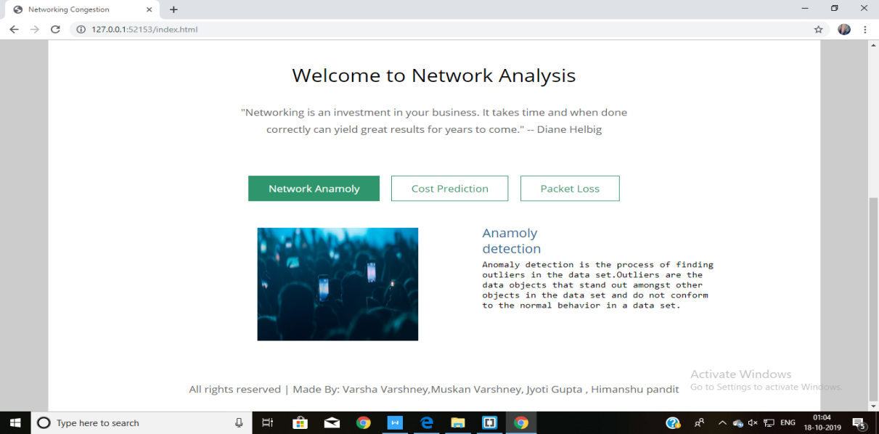

Fig. Home Page

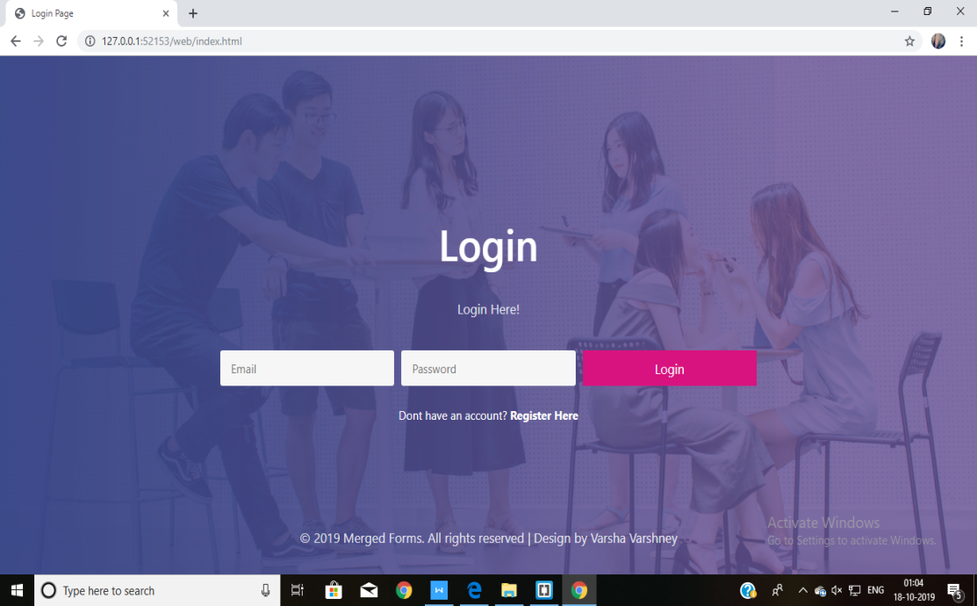

Fig.User Log-in Page



Fig.User Sign-In Page



Fig.Dasboard Page

Methodology



First, we meet directly with you.  
We work together, brainstorming about your project or idea.



Then, we analyze your requirements and split them

into atomic tasks, building the Backlog.



Prioritizing your requirements, we set milestones,

and split them into groups named Sprints, that will take 2 weeks.



After a Sprint ends, we review it together, and then we

organize the next Sprint.

**Contribution Summary**

**Further Evalution**

In this project, PHP and MYSQL both are used for the backend. PHP is used for the web development and MYSQL is used for the database.

Hypertext Preprocessor is a general-purpose programming language which is orginally designed for web development .It is a server side scripting language that is used to develop web application. PHP scripts can only be interpreted on a server that has PHP installed.

SQL is used for the database .It is used to generate queries from client program to the database. This can allow the users to execute a wide range of fast data manipulation.So,to basically put it, SQL is the main language that allows your database servers to store & edit the data on it.

In this project, PHPis used in Login and Registration page.SQL is used to store the data for further use and further validation. User authentication is very common in web application. It is a security mechanism that is used to restrict the unauthorized to member-only areas and tools on a site.

We’ve used the Bootstrap framework to make the form layouts quickly and beautifully. It includes HTML and CSS basesd design templates for image , button ,typography etc. It also gives you support for JavaScript plugins. Bootstrap’s responsive CSS adjusts to phones, tablets, and desktops.

We’ve also used the jQuery, to improve the performance of the application.It helps to implement UI related critical functionality without writing hundreds of lines of codes. It is fast . It is extensible in nature.jQuery is a JavaScript library tha helps to simplify and standardize interactions between JavaScript code and HTML elements. jQuery is a tool that helps streamline that process. jQuery simplifies HTML document traversing, event handling, animating, and Ajax interactions for rapid web development. jQuery is easier to use compared to JavaScript and its other JavaScript libraries. You need to write fewer line of code while using jQuery, in comparison with JavaScript.

**Appendixes : References**

* <https://jacekjeznach.com/>
* <https://www.hotjar.com/analytics?utm_campaign=HJ-India->
* <https://www.cyberworx.in/>
* Github id- https://github.com/Fullstack-A-33-80-C-28-D-29/Online-Analysis-Website